# Literature review

## Introduction

With the increasing number of natural disasters, the demand for volunteers is increasing. Organizations struggle to find new volunteers and to keep existing ones. I will create a website focusing on the United States where both nonprofits and volunteers can register their profile. Nonprofits can register their events while individuals can send their applications. This allows multiple organizations to browse volunteers based on their skills and other criteria. It will also enable volunteers search and find different opportunities from multiple organizations with a single access. This way individuals may partake in more events and organizations can reach out to a bigger population to highlight their cause and attract more help.

## Evaluation of previous work and available analysis of volunteering

### United states billion-dollar disaster events

Based on NOAA’s (National Oceanic and Atmospheric Administration U.S. Department of Commerce) National Centers for Environmental Information Climate Monitoring site, the billion-dollar disaster events in the United States has been increased significantly in the last decades. “The 1980–2023 annual average is 8.5 events; the annual average for the most recent 5 years (2019–2023) is 20.4 events.”[1]. The authors collected and analyzed 400 weather disaster events which exceeds $1 billion in damage in the U.S. between 1980 and 2024. This can be seen on Fig. 1 provided by the report.

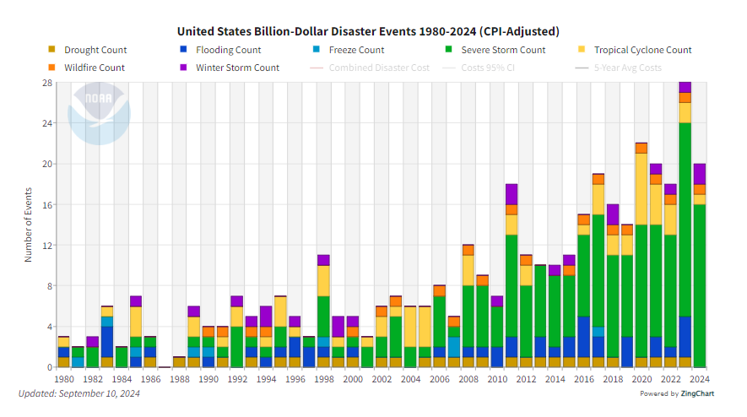

Fig. 1, United States Billion-Dollar Disaster Events 1980-2024

Based on the dataset provided by NOAA, I created a different chart (Fig. 2) to highlight the main tendency over decades and the last 1-3-5 year period. In the 1980s (1980-1989) the average billion-dollar event was 3.3 yearly, and the cost was $21.9B. During the time it has been increasing and in 2010s the average yearly number was almost doubled compared to the prior decade. The last 5/3/1 year periods are extremely high.

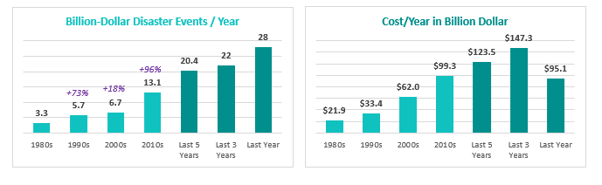

Fig. 2, United States Billion-Dollar Disaster Events per Year and Cost per Year

In the time of disaster volunteers help in various ways: clean up demolished homes and debris, take a role in making and distributing food, shelter management, mental health supporter, serve in logistics, healthcare, communication, rescue team, etc.

I’d like to demonstrate the need of a better approach to find and recruit volunteers as a nonprofit, as well as find events and opportunities as a volunteer. The upcoming analysis and reviews of different studies/articles/researches shows the challenges and narrows down the needs.

### Volunteering and Civic Life in America

According to the United States Census Bureau and the AmeriCorps research from 2023 (the research comes out every 2 years), more than 124 million people helped their neighbors informally between 2020 and 2021. It represents nearly 51% of the US population. It also says that “those who formally volunteered gave more than 4.1 billion hours of service with an estimated economic value of $122.9 billion”.[2] The main problem is that all statistics shows a decrease in volunteer numbers. The AmeriCorps research reported significant drop in the formal volunteering rate from 30% to 23.2%. These findings are based on data collected in September of 2017, 2019, and 2021. They reflect weighted state-level rates of four key measures of civic engagement. According to AmeriCorps’s research, these are:

* Formal Volunteering: the share of state residents who formally volunteered through organizations
* Informal Helping: the share of state residents who informally helped others by exchanging favors with their neighbors
* Organizational Membership: the share of state residents who belonged to an organization
* Charitable Giving: the share of state residents who donated $25 or more to charity.

[2]

On Fig. 3. I represent their findings on charts so that the decline is more visible.

Fig. 3, Decline in Volunteering based on AmeriCorps’s data

The United States Census Bureau holds the largest collection of demographic and economic data in the nation, and its data can be trusted in a study because it is collected through rigorous, standardized methods and produced by a reputable government agency dedicated to providing accurate, comprehensive national statistics.

### A Closer Look at nonprofits

Based on the 2024 Nonprofit Leadership Impact Study by NonProfit Pro, nonprofits struggle with recruiting dedicated volunteers. It says that “a third of respondents indicated they are unable to find and retain motivated volunteers who are passionate about their cause”. [3] According to the research the key challenges are shown on Fig. 4.

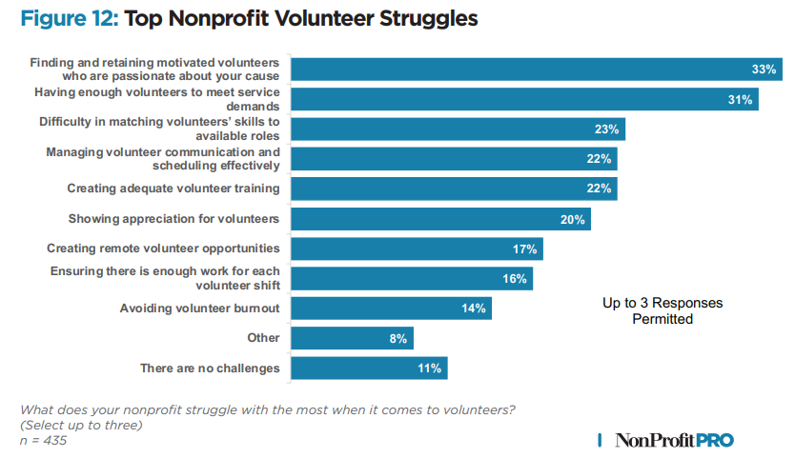

Fig. 4, Top Challenges of Nonprofits by NonProfit Pro

The top 4 categories clearly highlight nonprofit needs to find and retain the right volunteers. In my project, with every new registration the user signals their willingness to partake in volunteering for some cause. On a unified platform, organization demands can be satisfied as more people are available with a single registration. Volunteers will be able to provide their skills and organizations can find them which helps them to reach out to the right people. I plan to create a chat feature for each event separately which could address the communication challenge, but I’m not yet committed to implement it.

### A Closer Look at volunteers

Rosterfy is a volunteer management solution provider that connects their interface to the nonprofit’s own volunteer system. Their Volunteer Survey in March 2024[4] is a fresh research about volunteer motivation. Results are shown on Fig. 5.

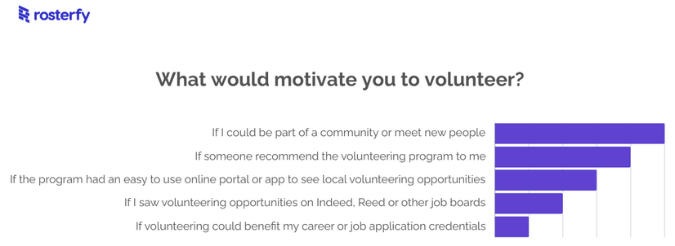

Fig. 5, Rosterfy’s March 2024 Survey for Volunteer Motivation

According to their result, volunteers prefer recommendation and an easy-to-use online portal with local opportunities. My implementation will support these requirements by providing searching opportunities based on distance as well as other factors. It will also have a recommendation feature where organizations and users will be able to send a given event to certain volunteers.

### American Red Cross’s volunteer page evaluation

American Red Cross (ARC) is one of the top 15 most trusted organizations out of 1.8 million nonprofits in the U.S. according to Morning Consult’s report of most trusted nonprofits 2024[5]. However, as their website is not designed only for their volunteer work, the application process for volunteering is not simple. Fig. 6, Fig. 7 and Fig. 8 shows that it is a three-step process to get to the basic search page.

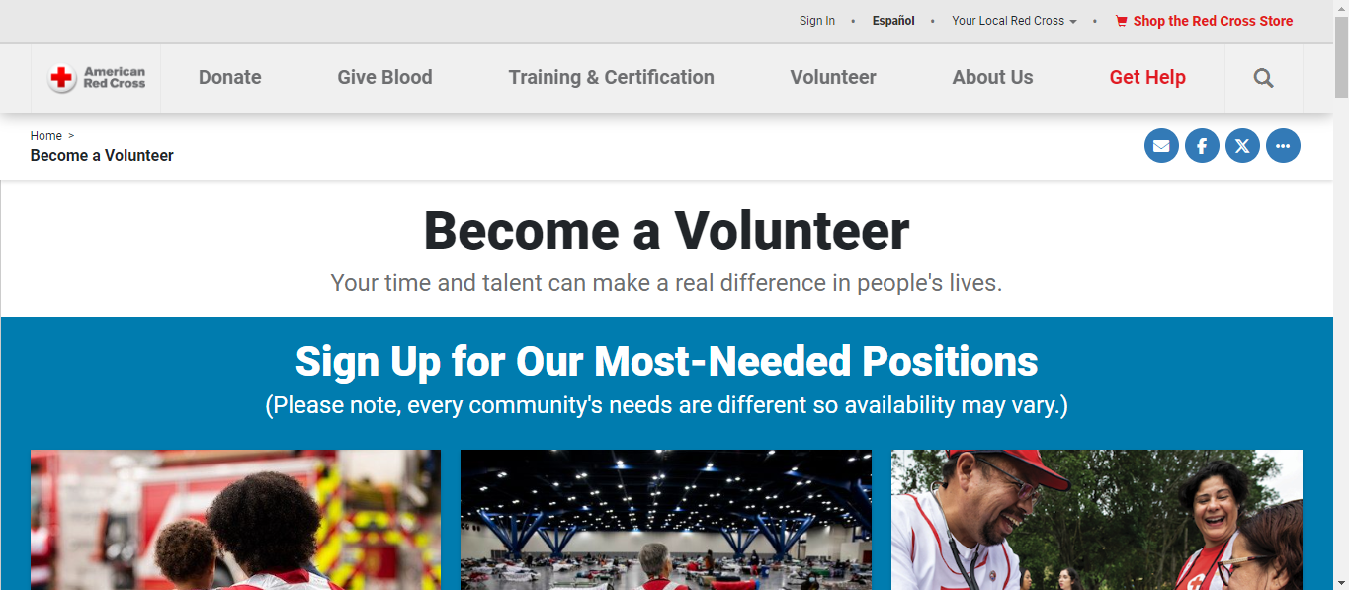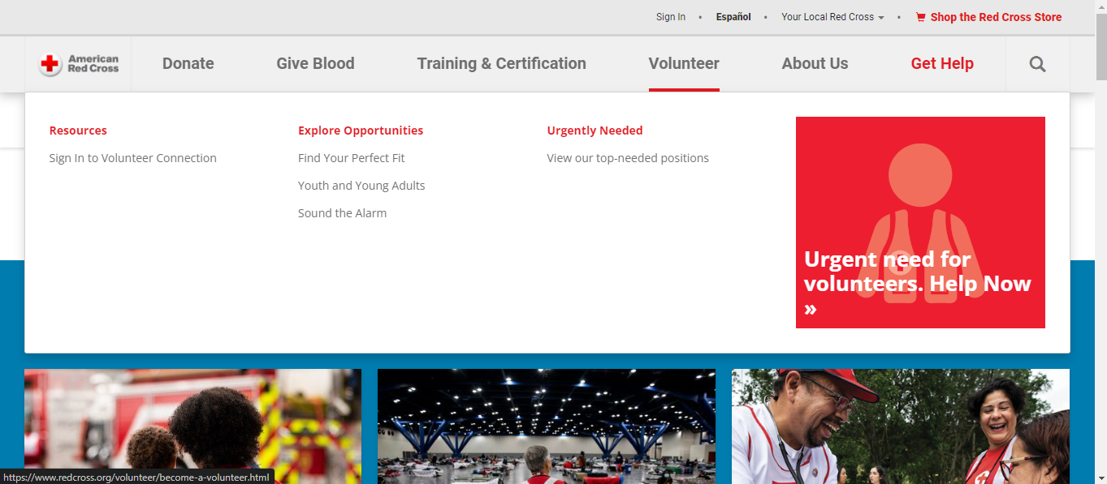

Fig. 6, ARC Home Page, Clicked on “Volunteer” Option

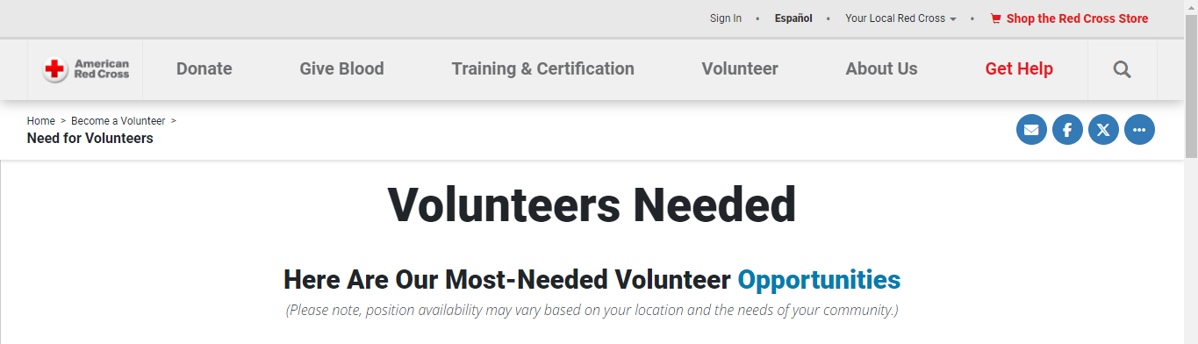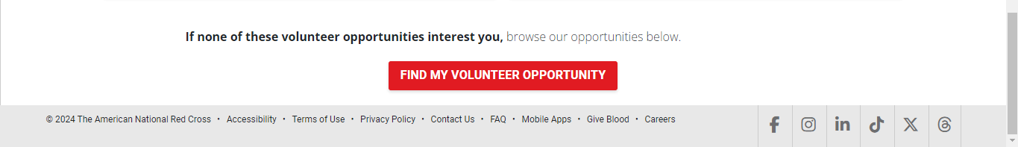

Fig. 7, ARC Site After Clicking on “Urgent need for volunteers. Help Now” Shown on Fig. 6.

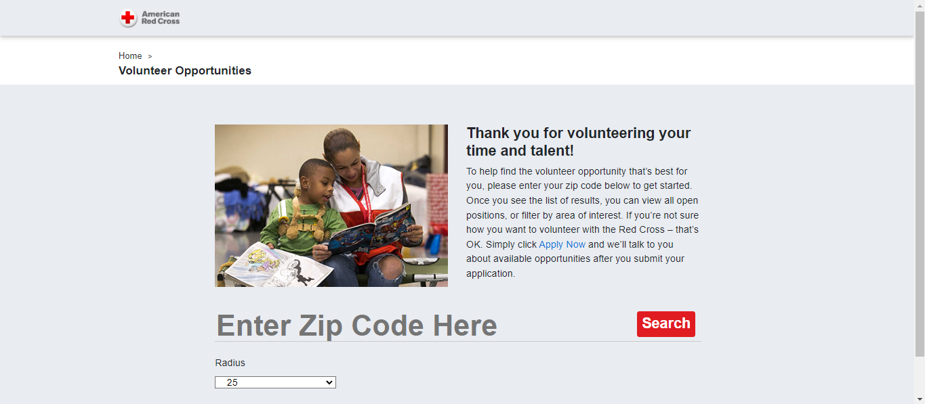

Fig. 8, ARC Site After Clicking on “Fing My Volunteer Opportunity” Shown on Fig. 7.

After following through these steps, the user still only can provide their Zip code and a radius within the opportunities are searched. Only after the first search new filter options are listed as shown on Fig. 9.

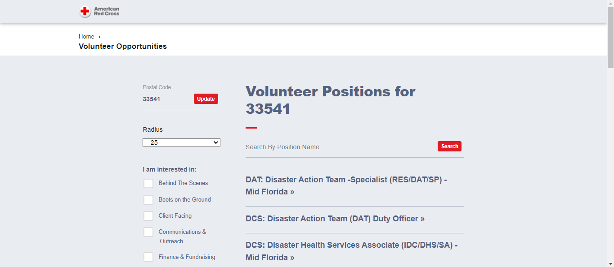

Fig. 9, ARC Page with Additional Filters After Search Was Pressed on Fig. 8.

Now there are a few causes are shown which would further limit the search result. If a user selects one, it shows more details about the given opportunity.   
However, at this point the missing parts are visible:

* It does not provide the recommendation option referred in Rosterfy’s report.
* Again, from Rosterfy the ease-of-use criteria is also questionable because of the multi-step and the limited search options.
* Similarly, as it does not support skill-based search, it also highlights the difficulty to match volunteer opportunities with volunteer skills from the NonProfit Pro study mentioned earlier.

Finally, the most obvious fact is that it only lists opportunities provided by American Red Cross. This means that if a volunteer is really determined to help, they might need to register to this site and others and go through the search process separately. That requires more time and effort from the volunteer. The more steps required, the more likely that the volunteer will just stop looking. This can be a reason why there is a decline in the number of volunteers and why organizations are struggling to find or retain them mentioned in earlier reviews. With a unified platform I propose, this can be resolved. While it requires organizations to register their events on my page, it simplifies the process from the volunteer’s perspective. They can search for events based on their skills or distance or cause, or even on event date and the results would include events from multiple organizations simplifying the search process. Organizations would benefit as well as they could get visibility from volunteers they not yet onboarded to their specific site. Also, with the reverse search – if user opts in - and recommendation system, they could reach out to the volunteers recommending certain events based on skills or distance that could help meet their demands.

## Techniques and methods

### Hardware

The project will be implemented on Oracle’s always free infrastructure. This includes a Linux virtual machine where I can host the server. It will be also relying on Oracle’s autonomous cloud database which is a reliable RDBMS that does not need separate infrastructure and is also part of the always free tier. It also supports various indexing and table partitioning options that allows scalability if the amount of data increase with the increasing number of organization and volunteer registrations and new events.

### Software

The project will be implemented using Django python framework that simplifies coding with its many built-in functions including database interactions and user authentications and security. It may be used with Nginx so that static files can be handled more effectively as well as handling multiple sessions more securely. If I will be implementing the chat feature, then I will be relying on Redis to provide live chat features for the events. Pages may also contain vanilla JavaScript to enhance front-end experience.

## Conclusion

The review process highlighted the increasing needs of volunteers as natural disasters keep increasing. It also showed organization struggles to reach out to more volunteers while volunteers prefer a simplified online platform with the ability to belong to a cause and keep up with the communication. A simple-to-use website that presents opportunities from multiple organizations with its recommendation system and chat can meet these criteria for both parties. Organizations can reach out to new volunteers mitigating their needs while volunteers have a one-stop-shop for more opportunities and can communicate with others partaking on the same events.

## References

1. National Oceanic and Atmospheric Administration (NOAA), National Centers for Environmental Information (NCEI). Accessed 2024. U.S. Billion-Dollar Weather and Climate Disasters (2024). <https://www.ncei.noaa.gov/access/billions/state-summary/US>
2. Tim J. Marshall (U.S. Census Bureau), Erin Schneider (AmeriCorps).  
   Accessed 11/11/2024.   
   Volunteering in America: New U.S. Census Bureau, AmeriCorps Research  
   <https://www.census.gov/library/stories/2023/01/volunteering-and-civic-life-in-america.html>
3. Amanda L. Cole (NonProfit PRO)  
   Accessed 11/11/2024.   
   40 Nonprofit Trends for 2024   
   2024 Nonprofit Leadership Impact study  
   <https://nonprofitpro.tradepub.com/free/w_nonp31&ch=ADNB> (PDF download)
4. Rosterfy  
   Accessed 11/11/2024.   
   Volunteer Survey Results: What Motivates Volunteers to Choose Your Program?  
   <https://www.rosterfy.com/blog/rosterfy-community-motivation-survey>
5. Morning Consult  
   Accessed 11/11/2024.   
   Most Trusted Nonprofits 2024  
   The Most Trusted Nonprofits in the U.S.  
   <https://pro.morningconsult.com/analyst-reports/most-trusted-nonprofits-2024>

## List of Figures

Fig. 1: National Oceanic and Atmospheric Administration (NOAA), National Centers for Environmental Information (NCEI).   
United States Billion-Dollar Disaster Events 1980-2024  
Accessed 11/11/2024.  
Retrieved from: <https://www.ncei.noaa.gov/access/billions/state-summary/US>

Fig. 2: Author is self, based on data on reference [1]  
United States Billion-Dollar Disaster Events per Year and Cost per Year  
Data accessed on 11/11/2024

Fig. 3: Author is self, based on data on reference [2]  
Decline in Volunteering based on AmeriCorps’s data  
Data accessed on 11/11/2024

Fig. 4: Amanda L. Cole (NonProfit PRO)  
Accessed on 11/11/2024.   
40 Nonprofit Trends for 2024   
2024 Nonprofit Leadership Impact study   
Top Challenges of Nonprofits by NonProfit Pro  
<https://nonprofitpro.tradepub.com/free/w_nonp31&ch=ADNB> (PDF download)

Fig. 5: Rosterfy  
Accessed 11/11/2024.   
Rosterfy’s March 2024 Survey for Volunteer Motivation  
<https://www.rosterfy.com/blog/rosterfy-community-motivation-survey>

Fig. 6: American Red Cross  
Accessed on 11/11/2024.   
ARC Home Page, Clicked on “Volunteer” Option  
<https://www.redcross.org/>

Fig. 7: American Red Cross  
Accessed on 11/11/2024.   
ARC Site After Clicking on “Urgent need for volunteers. Help Now” Shown on Fig. 6.  
<https://www.redcross.org/volunteer/become-a-volunteer/urgent-need-for-volunteers.html>

Fig. 8: American Red Cross  
Accessed on 11/11/2024.   
ARC Site After Clicking on “Fing My Volunteer Opportunity” Shown on Fig. 7.  
<https://volunteerconnection.redcross.org/?nd=rco_opportunity_browse_list>

Fig. 9: American Red Cross  
Accessed on 11/11/2024.   
ARC Page with Additional Filters After Search Was Pressed on Fig. 8  
<https://volunteerconnection.redcross.org/?nd=rco_opportunity_browse_list&postal_code=33541&op_search_radius=25>